**Category-Based Dynamic Form Creation and Submission System**

**Database Structure**

*Made by* ***Nafis Abdullah***

This document presents the DB structure for a **Category-Based Dynamic Form Creation and Submission System**. The system is designed to allow administrators to create custom forms based on specific categories, and users to submit those forms.

The database design is built with several key entities, including users, categories, forms, and form submissions. Each of these elements plays a role in ensuring the system remains flexible and secure, allowing multiple organizations to collect the data they need.

**Tables and Relationships**

Below is a detailed description of each table and how they relate to one another.

**a. Users Table**

This table holds all user data, including both admins and standard users who will fill out forms.

| **Column Name** | **Data Type** | **Description** |
| --- | --- | --- |
| **id** | INT (Primary Key) | Auto-incrementing ID for each user |
| **name** | VARCHAR(255) | The full name of the user |
| **email** | VARCHAR(255) | User’s unique email address |
| **password** | VARCHAR(255) | The hashed password for security |
| **role** | ENUM('admin', 'user') | Defines if the user is an admin or a regular user |
| **created_at** | TIMESTAMP | Timestamp when the user was created |
| **updated_at** | TIMESTAMP | Timestamp when the user information was last updated |

**b. Categories Table**

Each organization can define multiple categories, which serve as containers for different form templates.

| **Column Name** | **Data Type** | **Description** |
| --- | --- | --- |
| **id** | INT (Primary Key) | Auto-incrementing ID for each category |
| **name** | VARCHAR(255) | The name of the category |
| **description** | TEXT | A detailed description of the category |
| **created_by** | INT (Foreign Key) | References users.id, indicating which admin created the category |
| **created_at** | TIMESTAMP | Timestamp when the category was created |
| **updated_at** | TIMESTAMP | Timestamp when the category was last updated |

**c. Form Templates Table**

Form templates define the structure of each form under a specific category.

| **Column Name** | **Data Type** | **Description** |
| --- | --- | --- |
| **id** | INT (Primary Key) | Auto-incrementing ID for each form template |
| **name** | VARCHAR(255) | The name of the form template |
| **description** | TEXT | A description of what the form is for |
| **category_id** | INT (Foreign Key) | References categories.id, linking the form to a category |
| **created_by** | INT (Foreign Key) | References users.id, indicating the admin who created the form |
| **created_at** | TIMESTAMP | Timestamp when the form template was created |
| **updated_at** | TIMESTAMP | Timestamp when the form template was last updated |

**d. Form Fields Table**

Each form template consists of multiple fields (e.g., text input, radio buttons), defined here.

| **Column Name** | **Data Type** | **Description** |
| --- | --- | --- |
| **id** | INT (Primary Key) | Auto-incrementing ID for each form field |
| **form_template_id** | INT (Foreign Key) | References form_templates.id, linking the field to a specific form template |
| **label** | VARCHAR(255) | The field label (e.g., 'First Name', 'Email') |
| **type** | ENUM('text', 'number', 'checkbox', 'radio', 'select') | Type of input field |
| **options** | JSON (nullable) | Stores selectable options for fields like radio buttons, checkboxes, or dropdowns |
| **is_required** | BOOLEAN | Indicates if the field is mandatory |
| **created_at** | TIMESTAMP | Timestamp when the field was created |
| **updated_at** | TIMESTAMP | Timestamp when the field was last updated |

**e. Form Submissions Table**

Whenever a user submits a form, their submission is stored here.

| **Column Name** | **Data Type** | **Description** |
| --- | --- | --- |
| **id** | INT (Primary Key) | Auto-incrementing ID for each submission |
| **form_template_id** | INT (Foreign Key) | References form_templates.id, linking the submission to a form |
| **user_id** | INT (Foreign Key) | References users.id, indicating which user made the submission |
| **submitted_at** | TIMESTAMP | Timestamp when the submission was made |

**f. Form Field Responses Table**

Each user submission may include responses to multiple fields, stored in this table.

| **Column Name** | **Data Type** | **Description** |
| --- | --- | --- |
| **id** | INT (Primary Key) | Auto-incrementing ID for each response |
| **form_submission_id** | INT (Foreign Key) | References form_submissions.id, linking the response to a submission |
| **form_field_id** | INT (Foreign Key) | References form_fields.id, linking the response to a specific field |
| **response_value** | TEXT (nullable) | The value submitted by the user for the specific form field |
| **created_at** | TIMESTAMP | Time of response creation |

*There is more content on the next page.*

**ER Diagram**

Entity-Relationship Diagram of the DB structure:

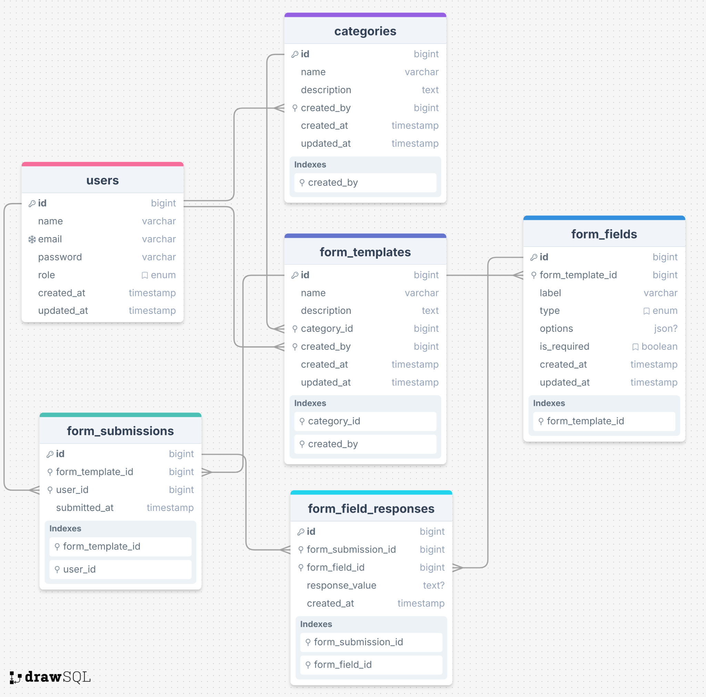

For a better view, visit [here](https://drawsql.app/teams/executive/diagrams/erd-for-form-creating-app).

**Conclusion**

The above database structure is designed to be easy to manage, flexible and adaptable which will enable administrators to create dynamic forms and users to submit data easily under different categories in a secure way. The relationships between tables ensure data integrity, while the separation of form templates, fields, and responses allows easy customization and data management.

So, by following this structure, organizations can collect and manage data from their users securely without much hassle.